***PROJECT REPORT***

1 INTRODUCTION:

1.1 OVERVIEW :

Our project is about the world’s top youtube channels. The ability to subscribe to users was introduced in October 2005.youtube began publishing a list of its most subscribed channels in April 2006. An early archive of the list dates to May 2006.

This project includes the comparison of the 50 most susbscribed youtube channels as well as the primary language , content category , ranks and the number of subscribers of each channel.

All 50 of the channels have surpassed 40 million subscribers, 39 of them have surpassed 50 million subscribers ,23 of them have surpassed 60 million subscribers , 16 of them have surpassed 70 million subscribers , 12 of them have surpassed 80 million subscribers , 10 of them have surpassed 90 million subscribers and 7 of them have surpassed 100 million subscribers. Only one of the channel( T-Series) has surpassed 200 million subscribers.

1.2 PURPOSE :

Youtube is an online video- sharing platform, where the users can upload ,view, and share all kinds of contents including video clips , flims , audio recordings , live streams and instructional videos.

It is also used for learning.it is a platform for learners.they can learn almost anything like languages, codings ,subjects, and so much more.

The main purpose of this project is to learn more about the youtube and its importance.

2 PROBLEM DEFINITION & DESIGN THINKING :

2.1 EMPATHY MAP

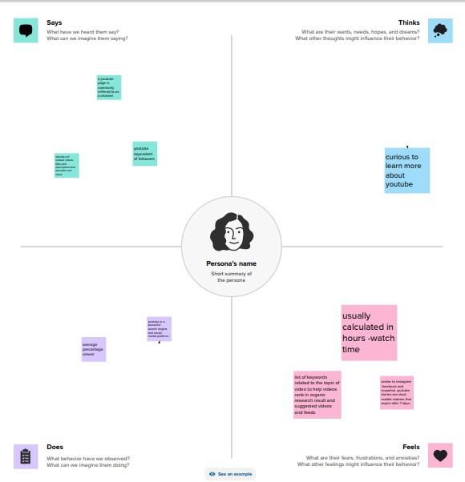

2.2 IDEATION & BRAINSTORMING MAP

BRAINSTORMING MAP

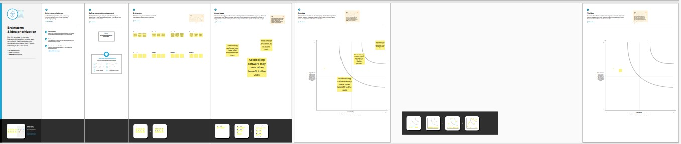

RESULT :

The result of this project follows:

Dashboard

The dashboard is a type of data visualization and often use common visualization tools such as graphs , charts and tables.it is a unique and powerful way to present data-based intelligence using data visualization.here it reveals all the comparison made in this project.

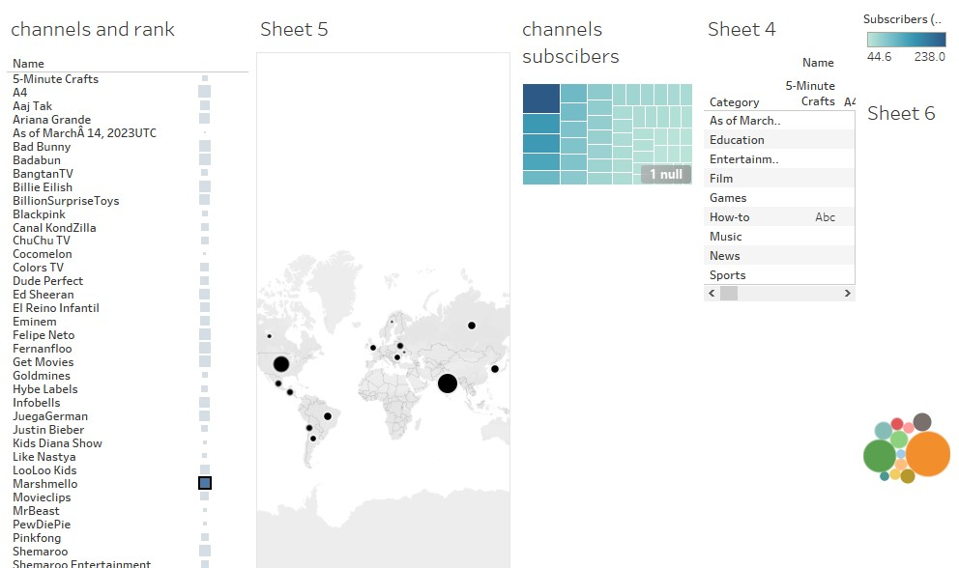

Sheet 1

This sheet compares the names of the channels and their ranks.

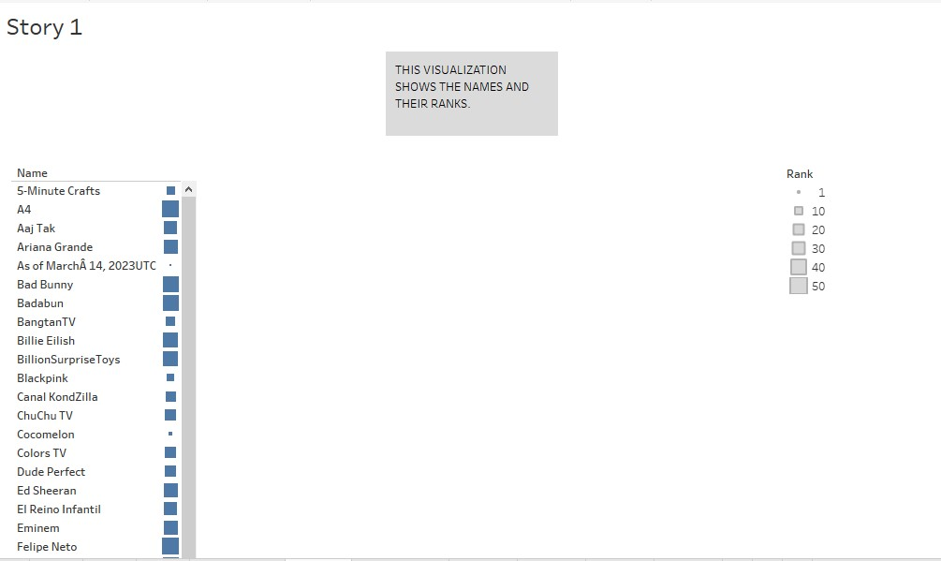

Sheet 2

This sheet is about the names of the channels and the subscribers.

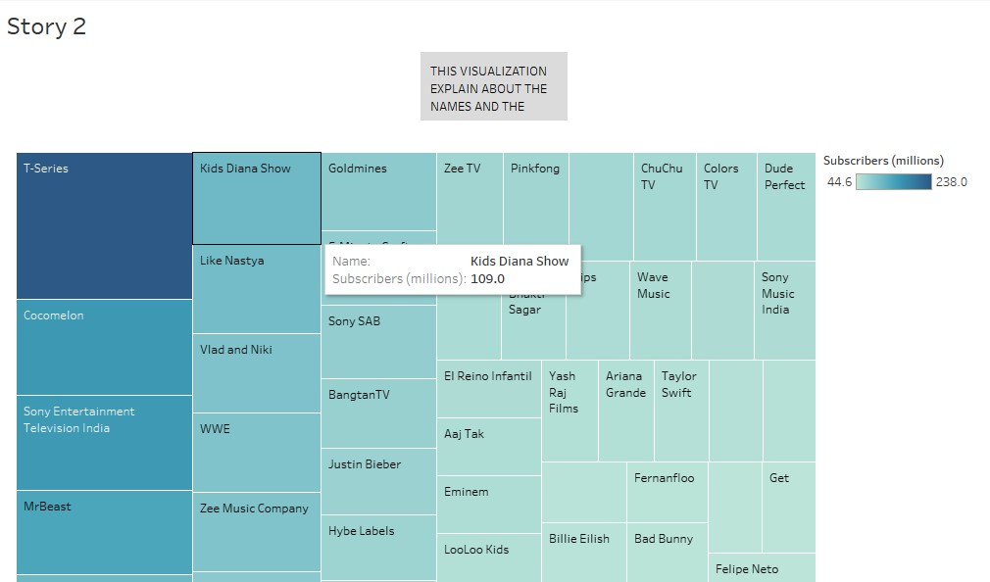

Sheet 3

This is about the names of the channels and its category.

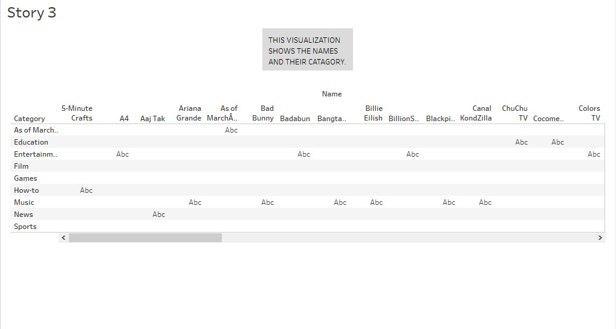

Sheet 4

This is about the countries and its rank.

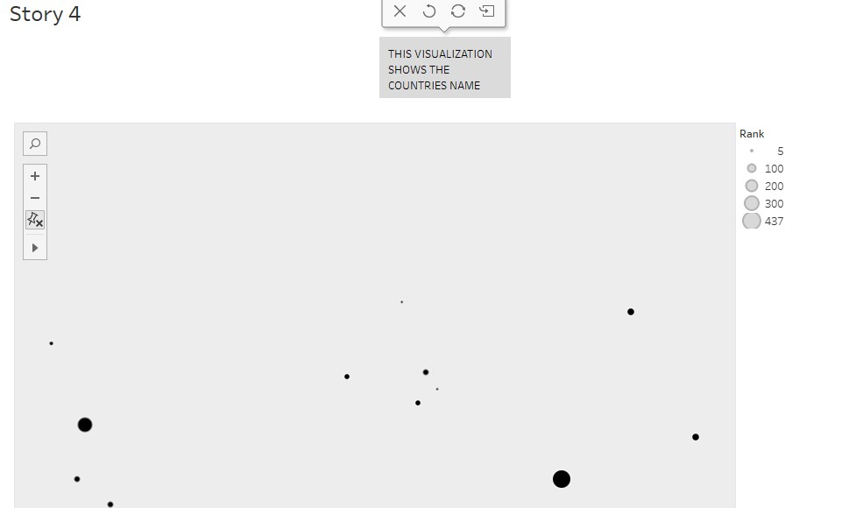

Sheet 5

This is about the countries and its primary language.

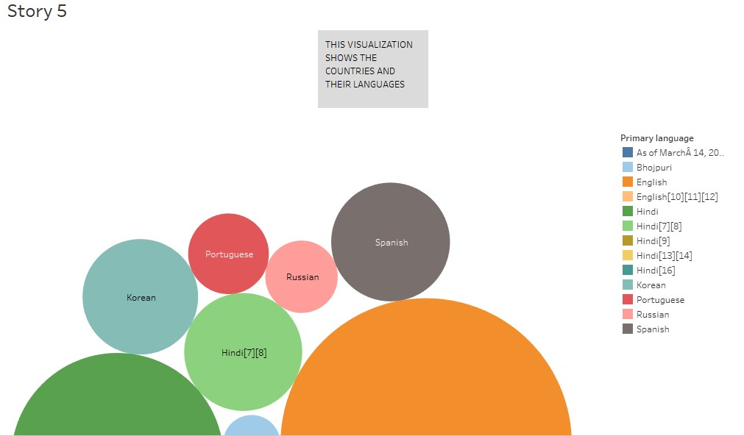

These are the results of this project.

ADVANTAGES & DISADVANTAGES :

ADVANTAGES

Youtube is a very popular and powerful social media to all generation of people.

Youtube is a simple and easiest way to learn .

It gives access to huge video contents.

It is easy to use and share contents with others.

It can be used for study purpose.

DISADVANTAGES

A huge advertisement takes place.

Everything is public.

Some accounts can be disabled without any reason.

Any advertisement can be uploaded in the middle of a video without any permission. This can hamper a creators videos and effect their followers.

Some content is adult rated but still the under-aged children can access it.

APPLICATIONS

It can be applied in the field of teaching, learning, earning, practicing social works, entertainment, guides etc.

CONCLUSION

We observe that the social behavior and interaction .

FUTURE SCOPE

We can earn easily by using youtube with smartwork.